Approving a Timecard as a Student Worker's Manager

To ensure accurate and timely payroll processing, all student workers must record their hours in Oracle and submit them for approval. Managers must then approve these hours for inclusion in payroll processing. Please ensure hours are approved by the Human Resources-designated deadline for each pay period to avoid delays in student payment. Below is the process for approving student worker timecards in Oracle:

**Please DO NOT use the “Team Time Cards” tile located in the My Team tab.**
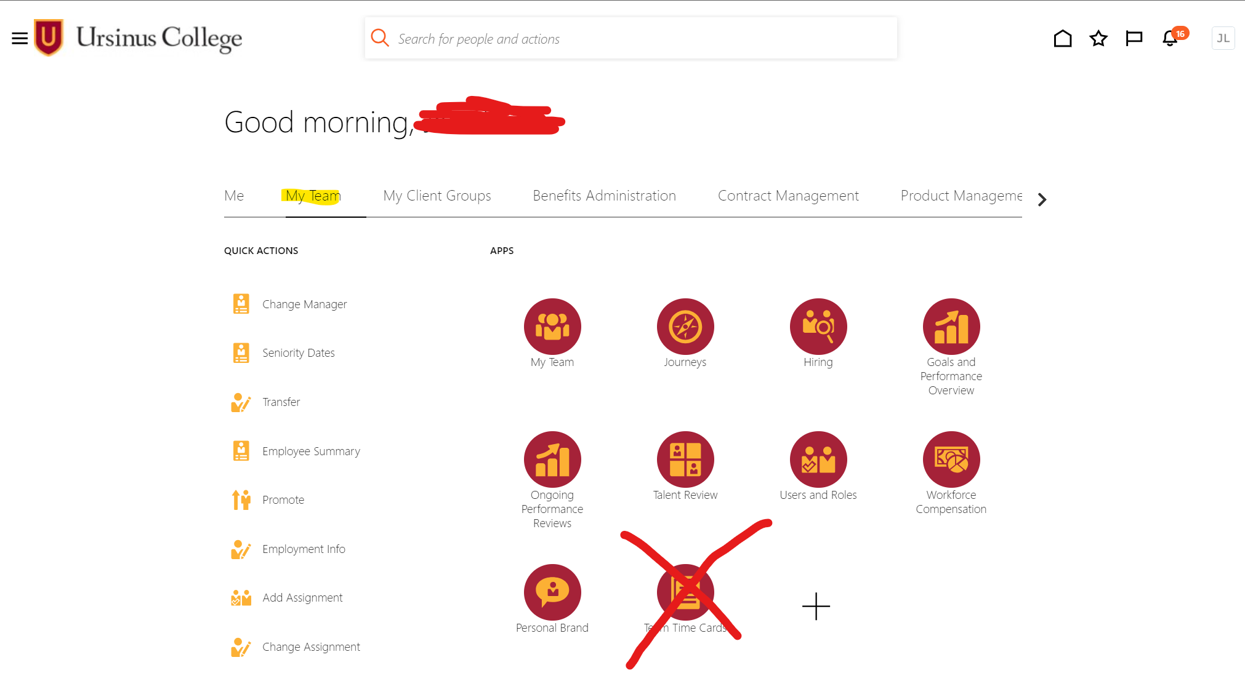

Approving Student Worker Timecards: A Guide for Managers
- Notification Bell: Click on your Notification Bell from your home screen.
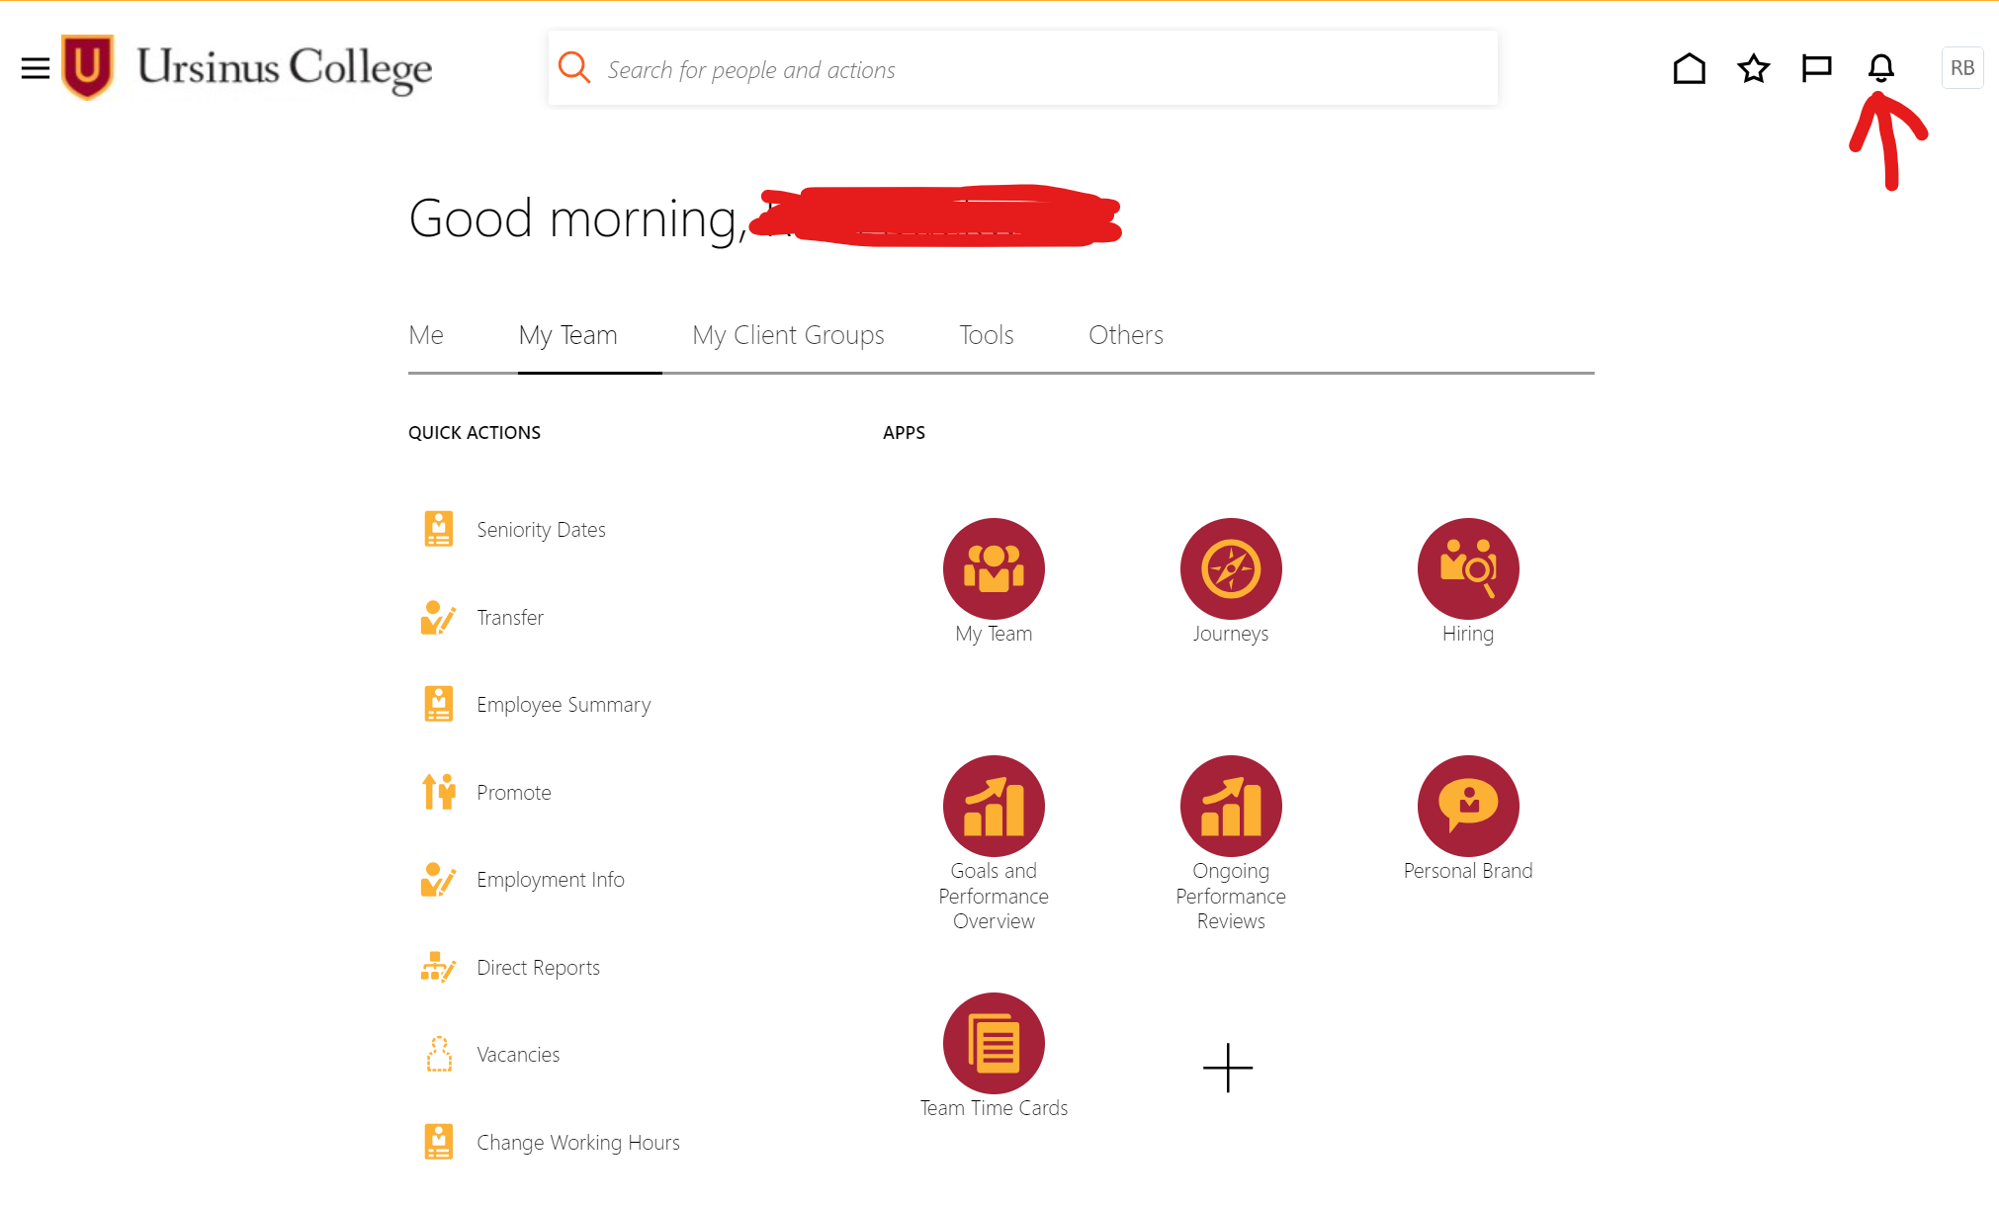
- Show All: In the dialog box, click on Show All.
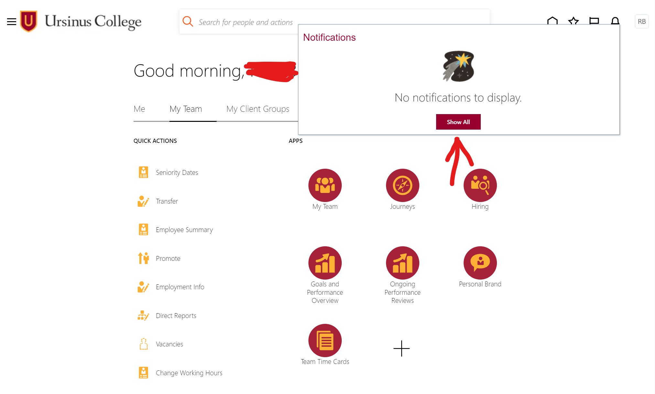
- Worklist: On the new page, click on Worklist.
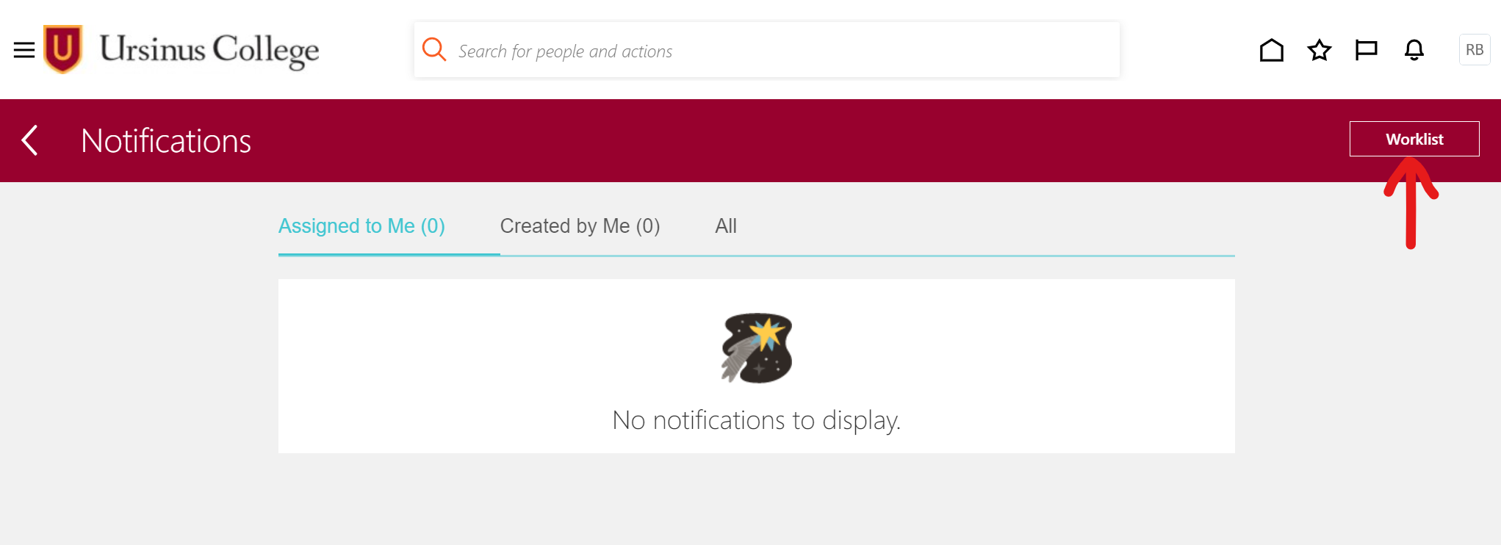
- BPM Worklist: This takes you to the BPM Worklist screen.
- My Tasks: In the Inbox list on the left, click on My Tasks. Your timecard approval
notifications will appear in My Tasks. Click on Approval of Payroll Time Entries to
view and approve your student’s hours.
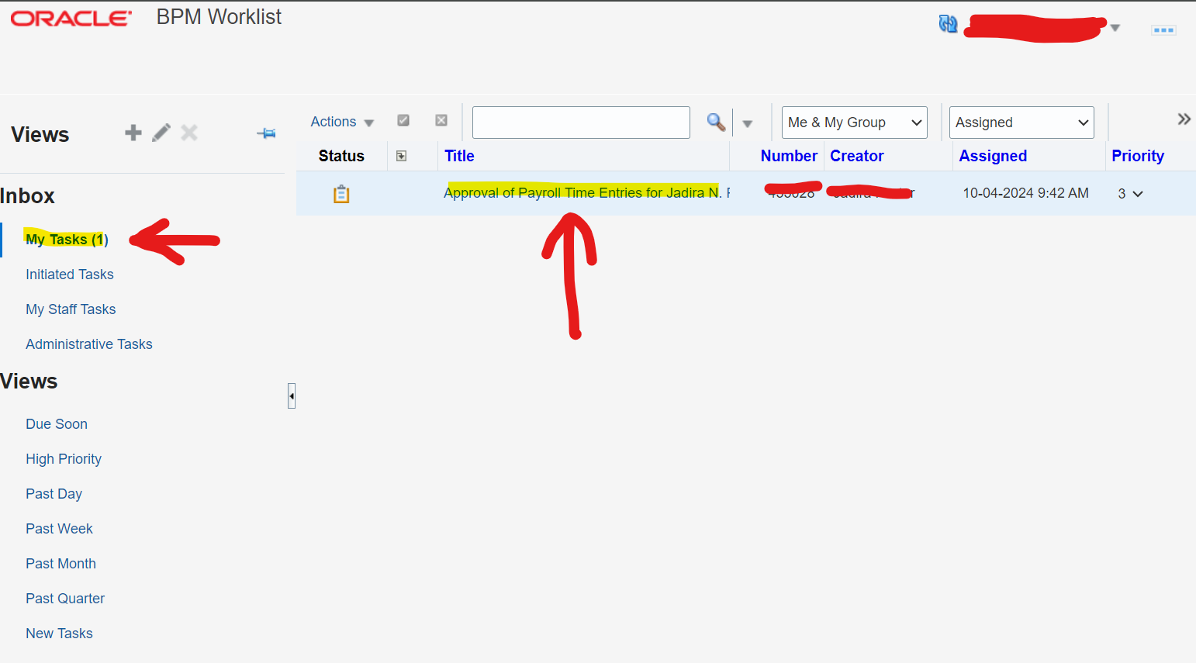
Note: Information under the Payroll Time Entries for Approval section may not show the assignment information for the assignment you manage. You can safely disregard this. You will be approving the hours listed.
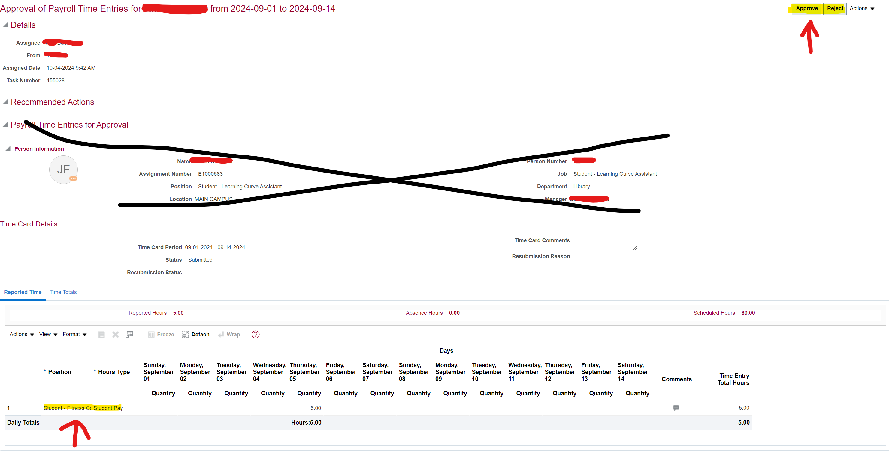
- Approve or Reject: At the top right, select either Approve or Reject for the listed hours.
- Payroll Processing: Approved hours will be processed in the next payroll run.
Email Notification: Alternatively, you can approve timecard hours directly from the email
notification received when the student submits their hours. Click on Access this task in the
Workspace Application at the top of the email to be taken directly to the hours that need
approval.


